# JavaScript for Front-End – Retake Exam Quotes

You have been tasked to create a simple Front-End application for making quotes. You should create an interface that allows users to create qoutes and choose there favourites.

## Task

The task is split into **2 sub-tasks**:

* A simple but fancy **web page design**.
* A simple but dynamic **web page functionality**.

The clients are understanding people, and they understand that you are quite novice as a developer, so they are willing to accept **ONLY** the **web page design** (without **functionality**) or **ONLY** the **web page functionality** (without **design**), if you are **unable** to **implement** one or the other.

## Overview

### Web Page Design

You are given the HTML file that looks like this **WITHOUT design**:

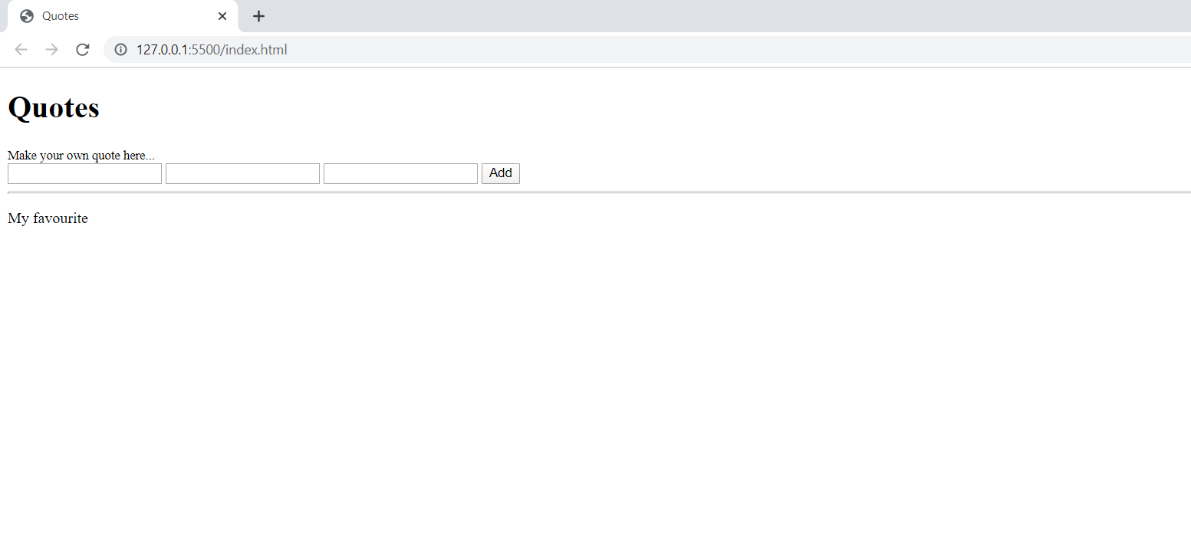

The web page should look like this **WITH design**:

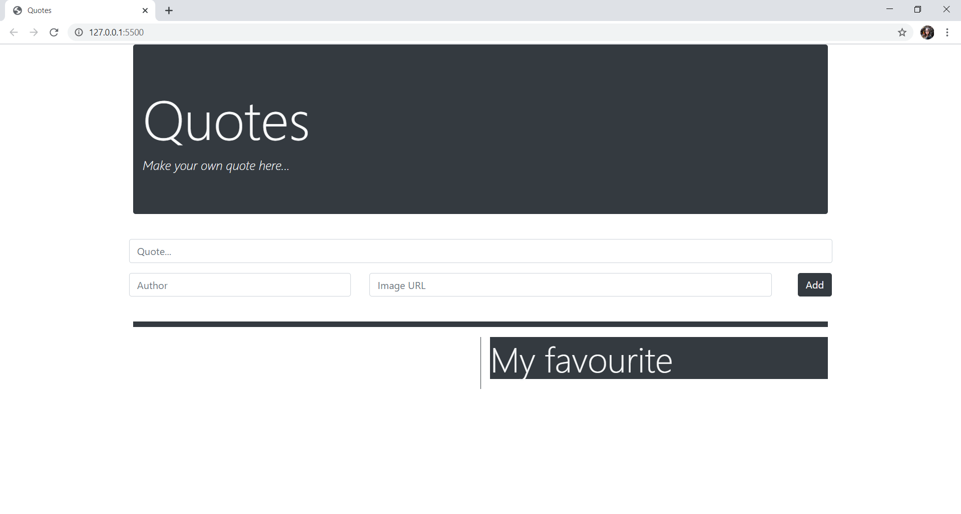

### Web Page Functionality

The application contains the following **functionality** – **creats a quote** and **displays it.**

The application should provide functionality to **create a quote** by using tree input fields. User shoud allways enter the **text** of a **quote**, but **author** and image **url** if there any. The **placeholder** **attribute** should be same as given above.

Here are example of creating a quote:

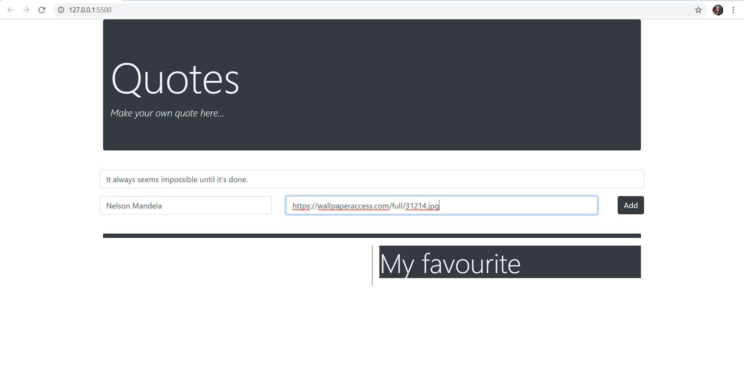

When [Add] button is checked **empty all of the text fields** and display the collected data like this:

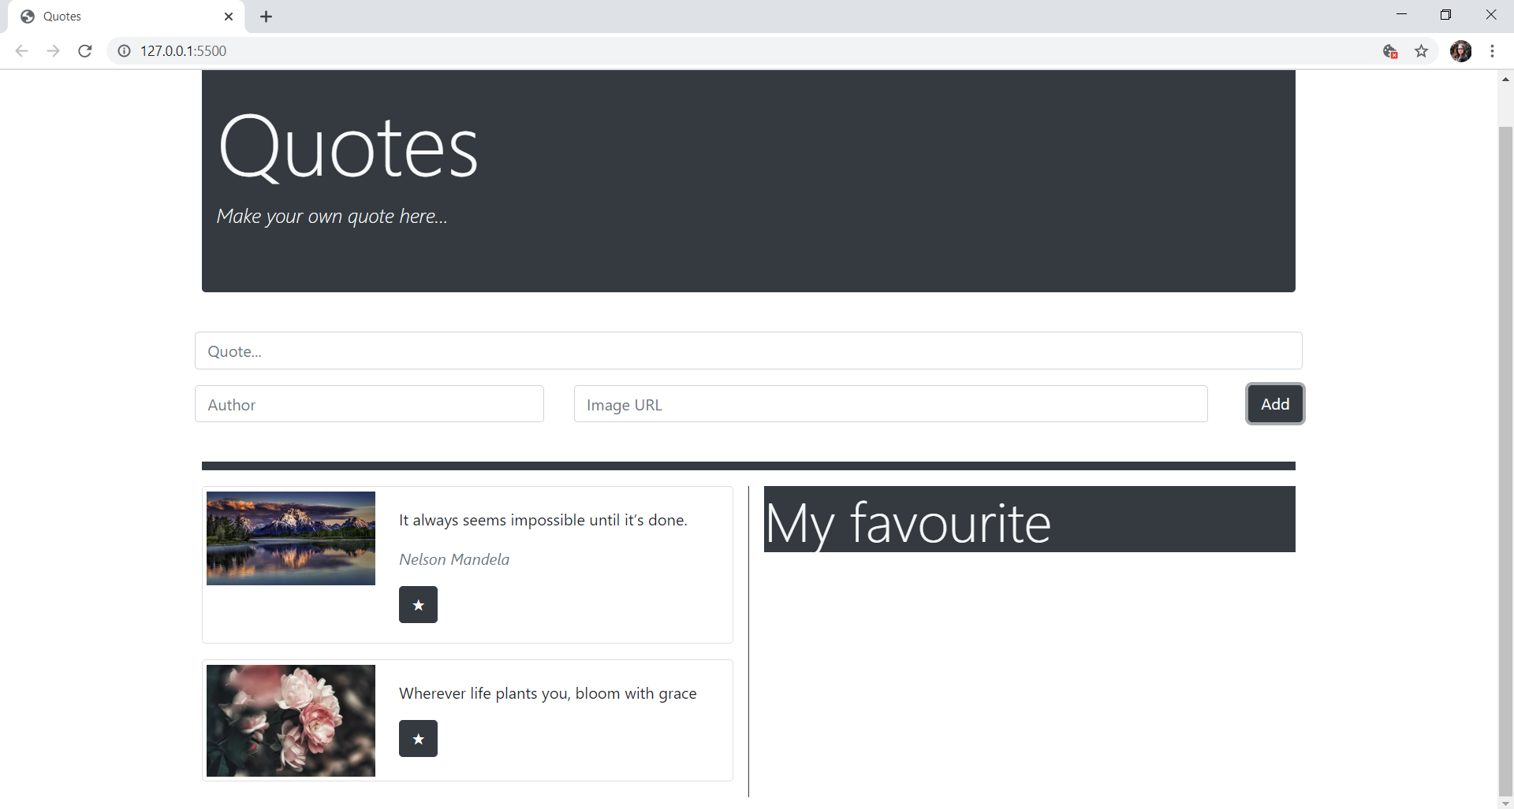

To choose youre **favourite** qoute and place it in the **right colomn** you enter the [★] button.

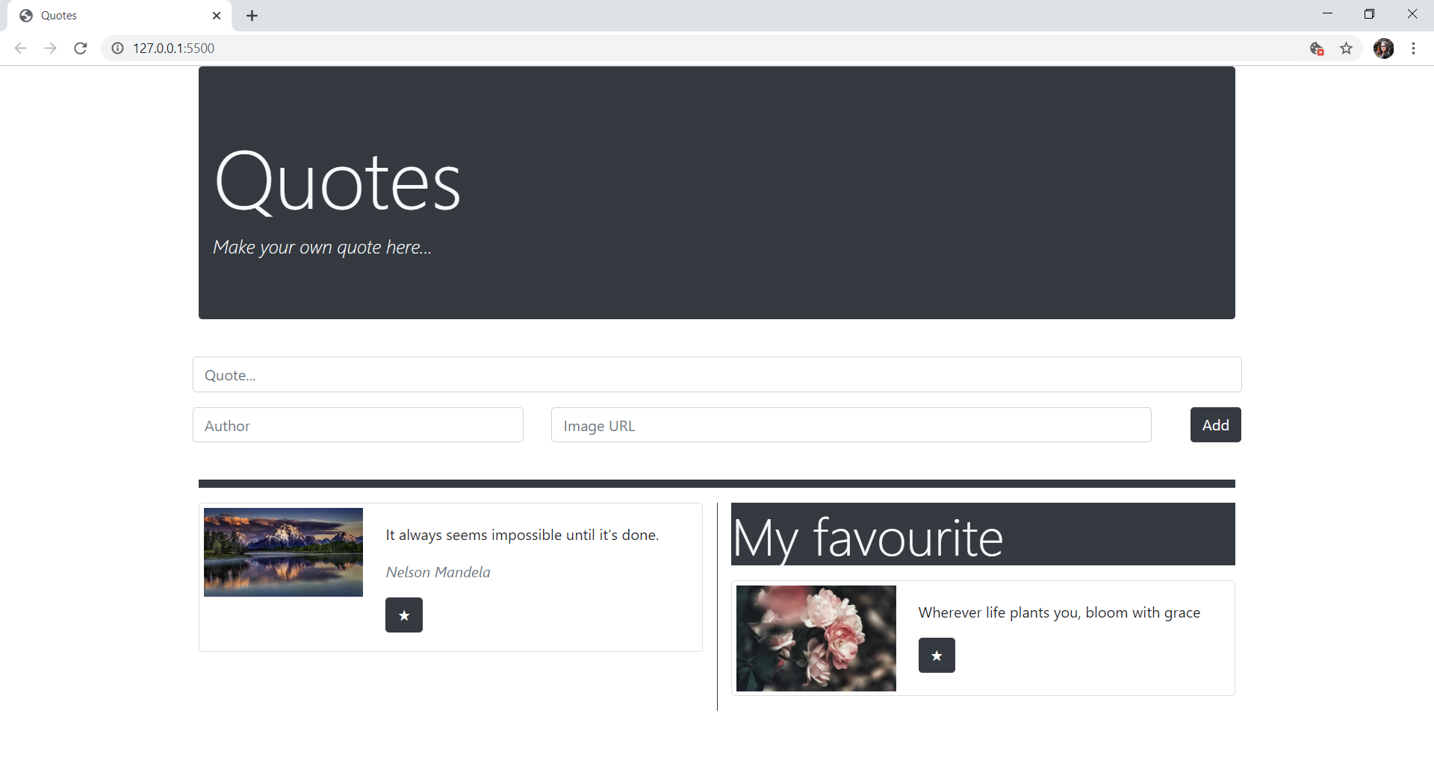

## Constraints

* You must use **ONLY** **Bootstrap** for the **web page design**.
* You must use **ONLY** native **JavaScript** for the **web page functionality**.

## Hint

You can display the star symbol using '★' or '\u2605'.

## Submitting Your Solution

ZIP your project. Upload the archive to Judge system.